**Project Report**

**On**

**AI Virtual Assistant**

**Using Python**

**Under**

**HPKVN Sponsored Training on**

**AI with Python**

**23.02.2023 to 24.05.2023**

|  |  |
| --- | --- |
|  |  |
| **Submitted by:**  Anuj Sharma & Nishant Thakur | **Project Mentor Name:**  Er. Himani |
| **hpkvn logo.png** | **C-DAC Round logo_1.jpg** |

**Education & Training Division (ETD)  
Centre for Development of Advanced Computing (C-DAC)  
(Ministry of Electronics & Information Technology, Govt. of India)  
A-34, Phase-VIII, Industrial Area, Mohali (160071)**

**Table of Contents**

|  |  |
| --- | --- |
|  | **Page No.** |
| 1. **Introduction** | **3-4** |
| 1. **Problem statement** | **5-6** |
| 1. **Objectives** | **7-8** |
| 1. **Design Methodology (Block Diagram or Work flow)** | **9-10** |
| **5 Dataset Explanation** | **11** |
| **6 Results – Front end clips, back end design clips etc** | **12-16** |
| **7 Conclusion** | **17** |
| **8 References** | **18** |

**Introduction**

Artificial Intelligence when used with machines, it shows us the capability of thinking like humans. In this, a computer system is designed in such a way that typically requires interaction from human. As we know Python is an emerging language so it becomes easy to write a script for Voice Assistant in Python. The instructions for the assistant can be handled as per the requirement of user. Speech recognition is the Alexa, Siri, etc. In Python there is an API called Speech Recognition which allows us to convert speech into text. It was an interesting task to make my own assistant. It became easier to send emails without typing any word, Searching on Google without opening the browser, and performing many other daily tasks like playing music, opening your favorite IDE with the help of a single voice command. In the current scenario, advancement in technologies are such that they can perform any task with same effectiveness or can say more effectively than us. By making this project, I realized that the concept of AI in every field is decreasing human effort and saving time.

As the voice assistant is using Artificial Intelligence hence the result that it is providing are highly accurate and efficient. The assistant can help to reduce human effort and consumes time while performing any task, they removed the concept of typing completely and behave as another individual to whom we are talking and asking to perform task. The assistant is no less than a human assistant but we can say that this is more effective and efficient to perform any task. The libraries and packages used to make this assistant focuses on the time complexities and reduces time.

The functionalities include , It can send emails, It can read PDF, It can send text on WhatsApp, It can open command prompt, your favorite IDE, notepad etc., It can play music, It can do Wikipedia searches for you, It can open websites like Google, YouTube, etc., in a web browser, It can give weather forecast, It can give desktop reminders of your choice. It can have some basic conversation.

Tools and technologies used are V S Code IDE for making this project, and I created all py files in PyCharm. Along with this I used following modules and libraries in my project. pyttsx3, SpeechRecognition, Datetime, Wikipedia, Smtplib, pywhatkit, pyjokes, pyPDF2, pyautogui, pyQt etc. I have created a live GUI for interacting with the JARVIS as it gives a design and interesting look while having the conversation.

In today’s era almost all tasks are digitalized. We have Smartphone in hands and it is nothing less than having world at your finger tips. These days we aren’t even using fingers. We just speak of the task and it is done. There exist systems where we can say Text Dad, “I’ll be late today.” And the text is sent. That is the task of a Virtual Assistant. It also supports specialized task such as booking a flight, or finding cheapest book online from various e- commerce sites and then providing an interface to book an order are helping automate search, discovery and online order operations.

Virtual Assistants are software programs that help you ease your day to day tasks, such as showing weather report, creating reminders, making shopping lists etc. They can take commands via text (online chat bots) or by voice. Voice based intelligent assistants need an invoking word or wake word to activate the listener, followed by the command. For my project the wake word is Jarvis. We have so many virtual assistants, such as Apple’s Siri, Amazon’s Alexa and Microsoft’s Cortana. For this project, wake word was chosen Jarvis.

Voice searches have dominated over text search. Web searches conducted via mobile devices have only just overtaken those carried out using a computer and the analysts are already predicting that 50% of searches will be via voice by 2020.Virtual assistants are turning out to be smarter than ever. Allow your intelligent assistant to make email work for you. Detect intent, pick out important information, automate processes, and deliver personalized responses.

This project was started on the premise that there is sufficient amount of openly available data and information on the web that can be utilized to build a virtual assistant that has access to making intelligent decisions for routine user activities

**Problem statement**

Now the basic question arises in mind that how it is an AI? The virtual assistant that we have created is like if it is not an A.I, but it is the output of a bundle of the statement. But fundamentally, the mail purpose of A.I machines is that it can perform human tasks with the same efficiency or even more efficiently than humans. It is a fact that my virtual assistant is not a very good example of A.I., but it is an A.I.

We are familiar with many existing voice assistants like Alexa, Siri, Google Assistant, Cortana which uses concept of language processing, and voice recognition. They listens the command given by the user as per their requirements and performs that specific function in a very efficient and effective manner. But they have major drawbacks.

For Example :

**SIRI from Apple** :SIRI does not maintain a knowledge database of its own and its understanding comes from the information captured in domain models and data models.

**ReQall** :Will take some time to put all of the to-do items in – you could spend more time putting the entries in than actually doing the revision. Etc

But for using These assistants one should have an account (like Google account for Google assistant, Microsoft account for Cortana) and can use it with internet connection only because these assistants are going to work with internet connectivity.They are integrated with many devices like, phones, laptops, and speakers etc

There already exist a number of desktop virtual assistants. A few examples of current virtual assistants available in market are discussed in this section along with the tasks they can provide and their drawbacks.

SIRI from Apple

SIRI is personal assistant software that interfaces with the user thru voice interface, recognizes commands and acts on them. It learns to adapt to user’s speech and thus improves voice recognition over time. It also tries to converse with the user when it does not identify the user request.It integrates with calendar, contacts and music library applications on the device and also integrates with GPS and camera on the device. It uses location, temporal, social and task based contexts, to personalize the agent behavior specifically to the user at a given point of time.

Supported Tasks

* Call someone from my contacts list
* Launch an application on my iPhone
* Send a text message to someone
* Set up a meeting on my calendar for 9am tomorrow
* Set an alarm for 5am tomorrow morning
* Play a specific song in my iTunes library
* Enter a new note

Drawback

SIRI does not maintain a knowledge database of its own and its understanding comes from the information captured in domain models and data models.

ReQall

ReQall is personal assistant software that runs on smartphones running Apple iOS or Google Android operating system. It helps user to recall notes as well as tasks within a location and time context. It records user inputs and converts them into commands, and monitors current stack of user tasks to proactively suggest actions while considering any changes in the environment. It also presents information based on the context of the user, as well as filter information to the user based on its learned understanding of the priority of that information.

Supported Tasks

* Reminders
* Email
* Calendar, Google Calendar
* Outlook
* Evernote
* Facebook, LinkedIn
* News Feeds

Drawback

Will take some time to put all of the to-do items in – you could spend more time putting the entries in than actually doing the revision.

**Objectives**

Main objective of building personal assistant software (a virtual assistant) is using semantic data sources available on the web, user generated content and providing knowledge from knowledge databases. The main purpose of an intelligent virtual assistant is to answer questions that users may have. This may be done in a business environment, for example, on the business website, with a chat interface. On the mobile platform, the intelligent virtual assistant is available as a call-button operated service where a voice asks the user “What can I do for you?” and then responds to verbal input.

Virtual assistants can tremendously save you time. We spend hours in online research and then making the report in our terms of understanding. Jarvis can do that for you. Provide a topic for research and continue with your tasks while Jarvis does the research. Another difficult task is to remember test dates, birthdates or anniversaries. It comes with a surprise when you enter the class and realize it is class test today. Just tell Jarvis in advance about your tests and she reminds you well in advance so you can prepare for the test.

One of the main advantages of voice searches is their rapidity. In fact, voice is reputed to be four times faster than a written search: whereas we can write about 40 words per minute, we are capable of speaking around 150 during the same period of time15. In this respect, the ability of personal assistants to accurately recognize spoken words is a prerequisite for them to be adopted by consumers

**PURPOSE, SCOPE AND APPILCABILITY**

##### **Purpose**

Purpose of virtual assistant is to being capable of voice interaction, music playback, making to-do lists, setting alarms, streaming podcasts, playing audiobooks, and providing weather, traffic, sports, and other real-time information, such as news. Virtual assistants enable users to speak natural language voice commands in order to operate the device and its apps.

There is an increased overall awareness and a higher level of comfort demonstrated specifically by millennial consumers. In this ever-evolving digital world where speed, efficiency, and convenience are constantly being optimized, it’s clear that we are moving towards less screen interaction.

##### **Scope:**

Voice assistants will continue to offer more *individualized* experiences as they get better at differentiating between voices. However, it’s not just developers that need to address the complexity of developing for voice as brands also need to understand the capabilities of each device and integration and if it makes sense for their specific brand. They will also need to focus on maintaining a user experience that is consistent within the coming years as complexity becomes more of a concern. This is because the visual interface with voice assistants is missing. Users simply cannot see or touch a voice interface.

##### **Applicability:**

The mass adoption of artificial intelligence in users’ everyday lives is also fueling the shift towards voice. The number of IoT devices such as smart thermostats and speakers are giving voice assistants more utility in a connected user’s life. Smart speakers are the number one way we are seeing voice being used. Many industry experts even predict that nearly every application will integrate voice technology in some way in the next 5 years.

The use of virtual assistants can also enhance the system of IoT (Internet of Things). Twenty years from now, Microsoft and its competitors will be offering personal digital assistants that will offer the services of a full-time employee usually reserved for the rich and famous.

**Design Methodology (Block Diagram or Work flow)**

**DATA FLOW :**

The data flow for JARVIS is as follow:



***Exit***

* It keeps on asking for the command from user until the user say "Quit". Once the user say "Quit", it exits.



***Start***

* Live GUI for interaction will appear on screen.

***Input***

* It will take input through voice commands related to the task which is required to be done.
* It will perform the required task for the user like opening notepad, searching on browser, sending

***Perform*** mails, playing songs etc.

**Figure: Data flow for JARVIS**

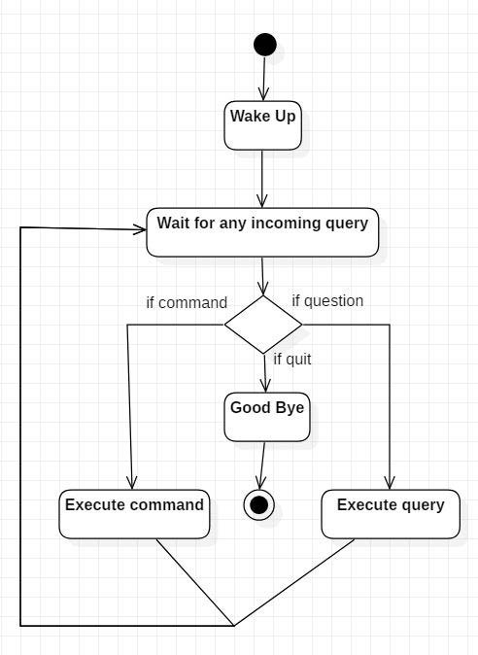**ACTIVITY DIAGRAM:**

**USE CASE DIAGRAM:**

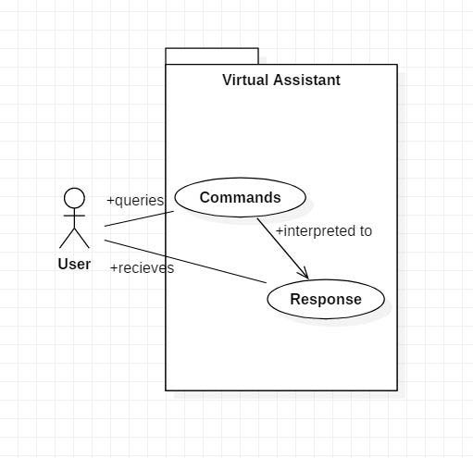

**Flow Diagram:**

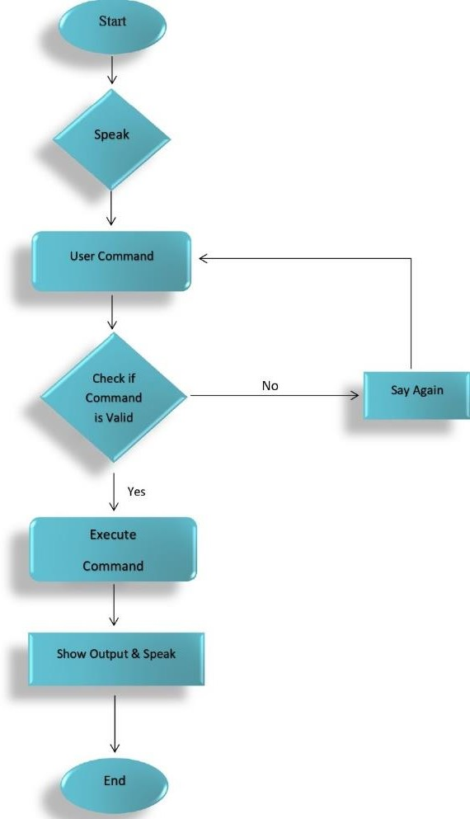

**Dataset Explanation**

In the Jarvis project, the specific use of a pre-defined dataset may not be required, as the focus is more on real-time interaction and leveraging online resources. However, there are some underlying data sources and APIs that Jarvis can access to gather information.

The Jarvis project, as a fictional AI assistant, doesn't have a specific API associated with it. However, to create a similar AI assistant like Jarvis, you can use various APIs to integrate different functionalities into your project. Here are some examples of APIs that you could use to implement features like fetching weather information, accessing trending movies, and generating random jokes:

1. **Weather API**: You can use weather APIs such as OpenWeatherMap, AccuWeather, or Weatherbit to retrieve weather information based on a location. These APIs allow you to access current weather conditions, forecasts, temperature, humidity, wind speed, and other relevant data.

2. **Movie API:** Services like The Movie Database (TMDb) or IMDb offer APIs that allow you to fetch information about movies, including details like movie titles, descriptions, ratings, release dates, cast and crew information, trailers, and more. You can use these APIs to retrieve information about trending movies, search for specific movies, or get details about popular films.

3. **Joke API**: Several APIs, such as JokeAPI, Official Joke API, or ICNDB (Internet Chuck Norris Database), provide random jokes or specific joke categories. These APIs allow you to fetch jokes in various formats, including text, JSON, or even programmatically generate jokes.

4. **Wikipedia:** Jarvis can utilize the Wikipedia API to retrieve information on various topics. It can query the API based on user requests and fetch summaries or specific details from Wikipedia articles.

To access these APIs, you typically need to register for an API key or authorization token. The API key helps to identify and authenticate your requests to the API service. Each API provider has its own documentation that explains how to make requests, what data you can expect in the responses, and any limitations or restrictions that apply.

**Results – Front end clips, back end design clips etc**

**Backend Softwares:-**

1. **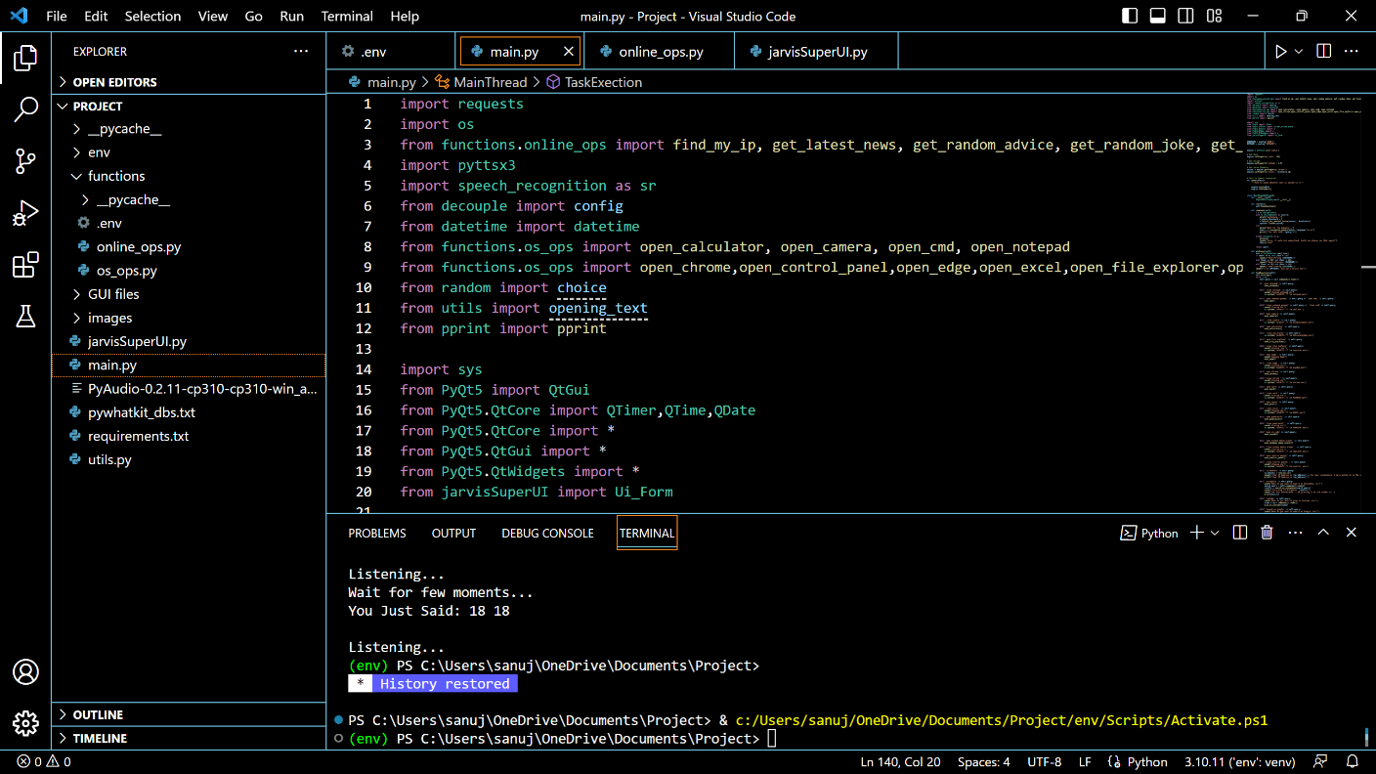VS Code:**

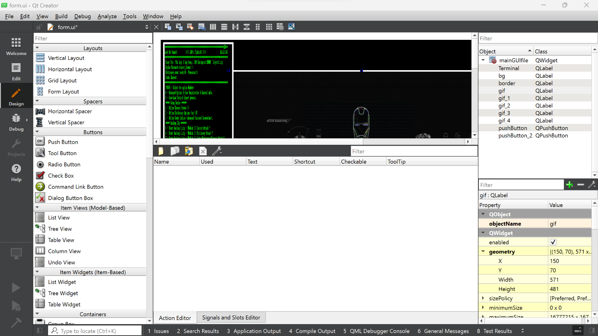

1. **QT Creator For GUI:**

**Figure 1 : Live GUI of JARVIS:**

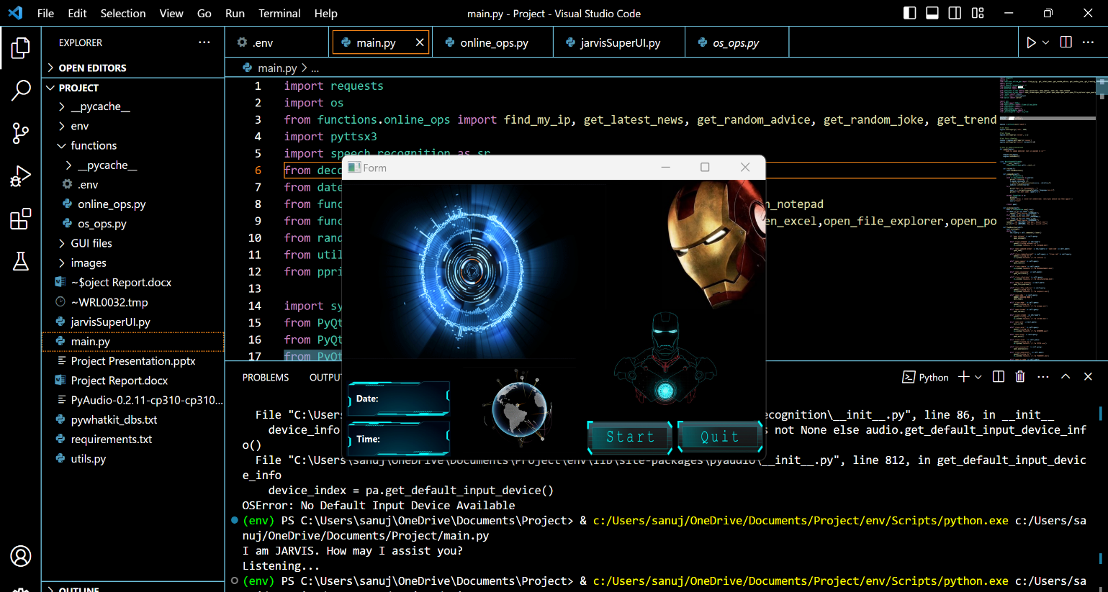

**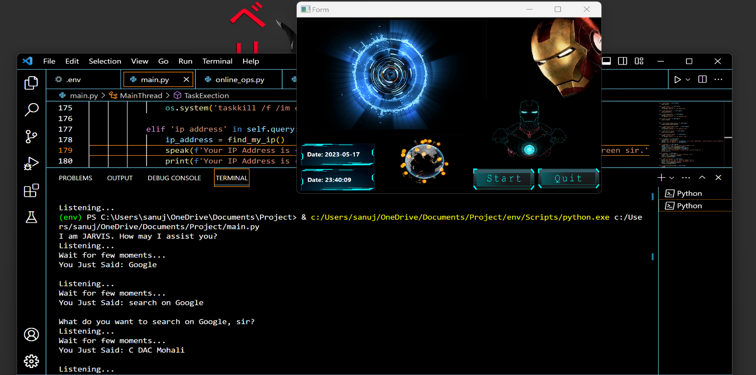Figure 2. Input for Google search:**

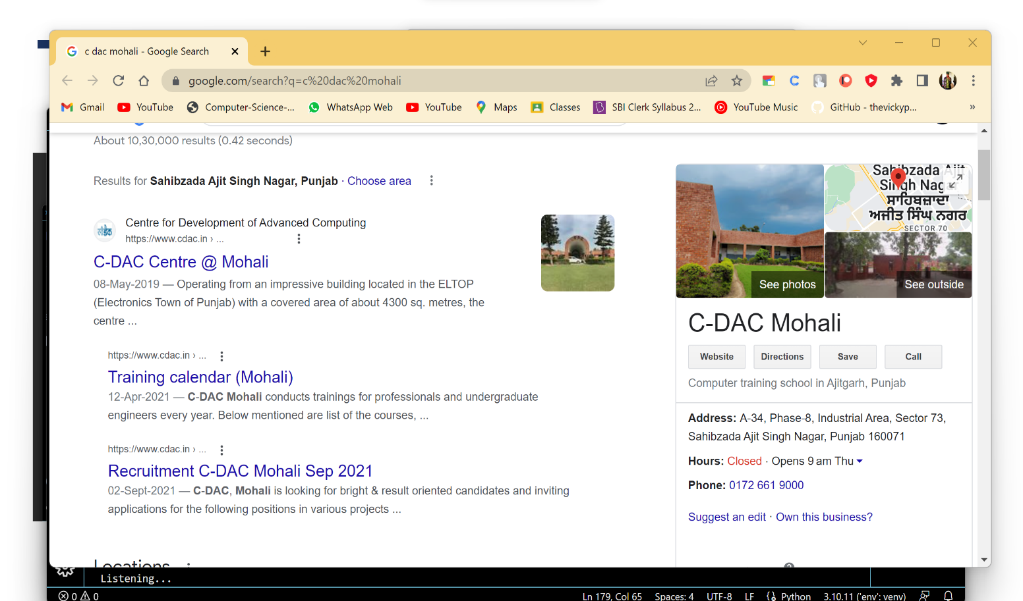**Figure 3: Output for Google search:**

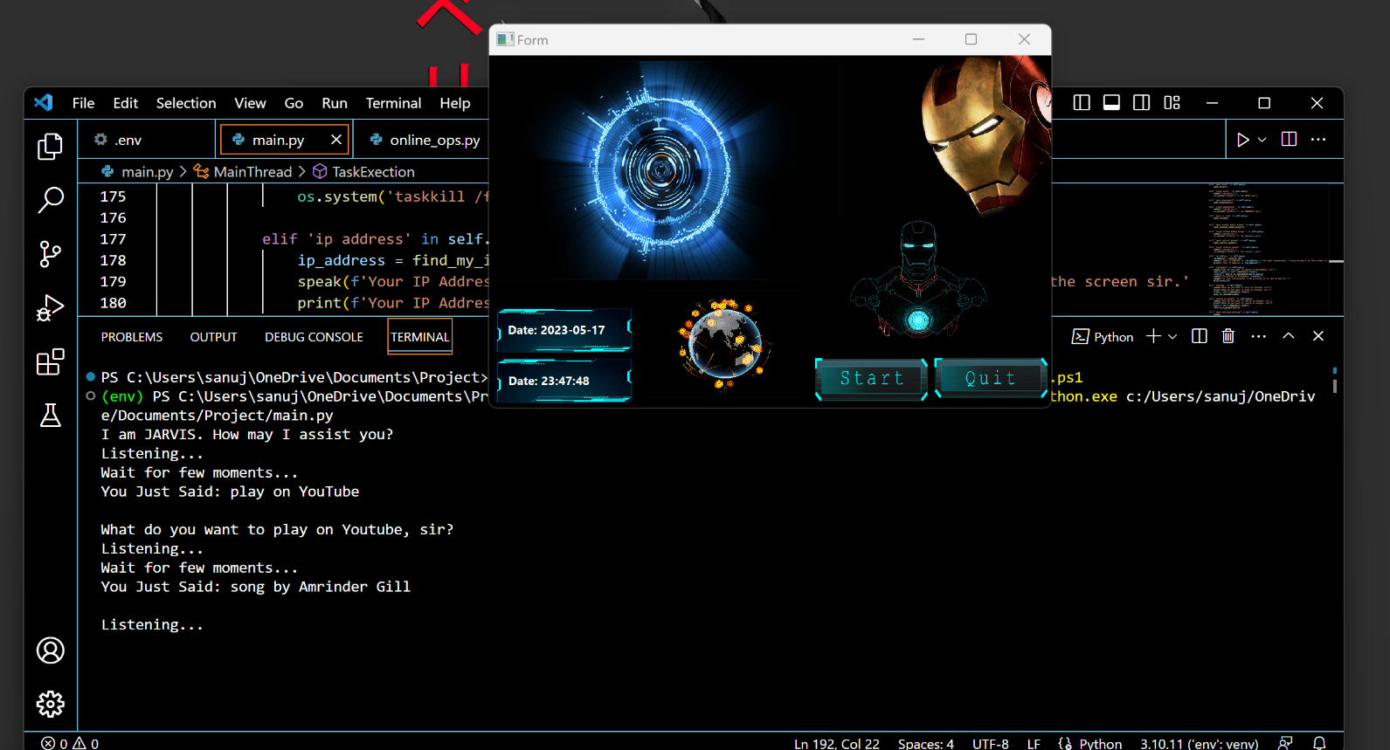**Figure 4: Input for Youtube search:**

**Figure 5: Output for Youtube search**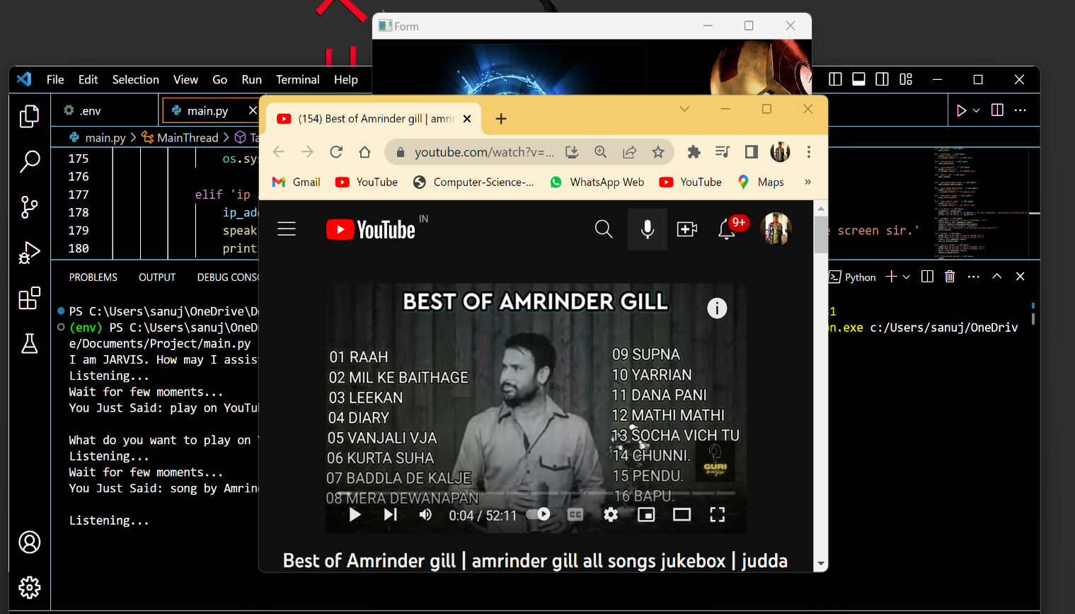**:**

**Figure 6: Input for Open CMD and Open Notepad**:

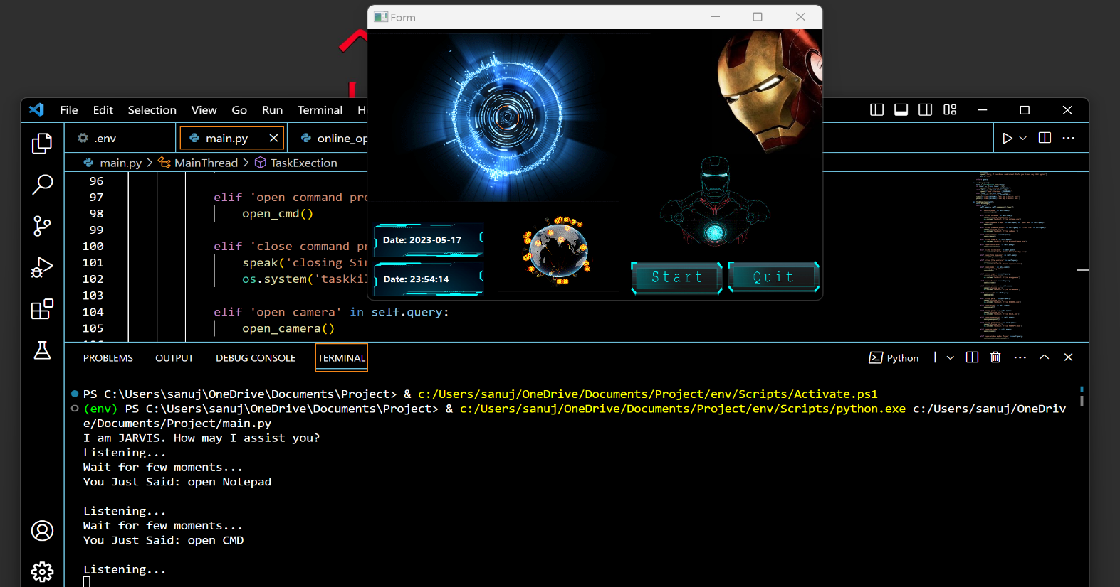

**Figure 7: Output for Open CMD and Open Notepad:**

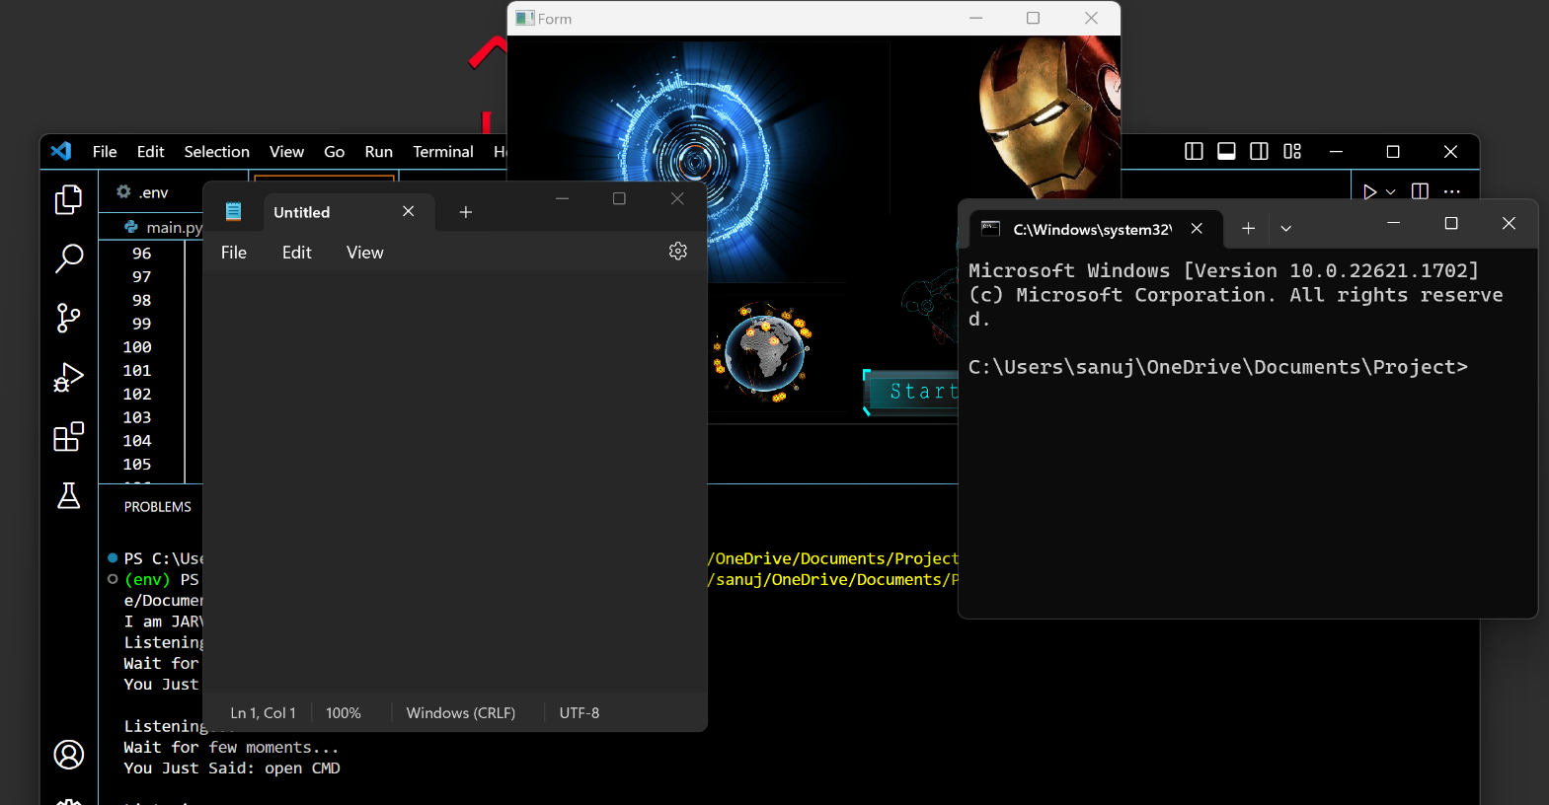

**Conclusion**

JARVIS is a very helpful voice assistant without any doubt as it saves time of the user by conversational interactions, its effectiveness and efficiency. But while working on this project, there were some limitations encountered and also realized some scope of enhancement in the future which are mentioned below:

**LIMITATIONS:**

* + - Security is somewhere an issue, there is no voice command encryption in this project.
    - Background voice can interfere
    - Misinterpretation because of accents and may cause inaccurate results.
* JARVIS cannot be called externally anytime like other traditional assistants like Google Assistant can be called just by saying, “Ok Google!”

**SCOPE FOR FUTURE WORK:**

* + - * Make JARVIS to learn more on its own and develop a new skill in it.
      * JARVIS android app can also be developed.
      * Make more Jarvis voice terminals.
      * Voice commands can be encrypted to maintain security.
      * We can Use Face recognition for the functioning or starting or jarvis

**References**

**1. Websites referred:**

* + [www.stackoverflow.com](http://www.stackoverflow.com/)
  + [www.pythonprogramming.net](http://www.pythonprogramming.net/)
  + [www.tutorialspoint.com](http://www.tutorialspoint.com/)

**2. Books referred:**

* + Python Programming - Kiran Gurbani
  + Learning Python - Mark Lutz

**3. YouTube Channels referred:**

* + Code with Harry
  + Kartis Technology